EXPERIMENT – 2

EXP NO 2: CREATE A SIMPLE CLOUD SOFTWARE APPLICATION FOR FLIGHT RESERVATION SYSTEM USING ANY CLOUD SERVICE PROVIDER TO DEMONSTRATE SAAS.
AIM:
To create a simple cloud software application for flight reservation system using
any cloud service provider to demonstrate saas.
PROCEDURE:
step1: Go to zoho.com.
step 2: Log into the zoho.com.
step 3: Select one application step.
step4: Enter application name as flight reservation system.
step 5: Created new application flight reservation system.
step 6: Select one form
step 7: The software has been created.
OUTPUT:
FORM 1 –Flight Details Form
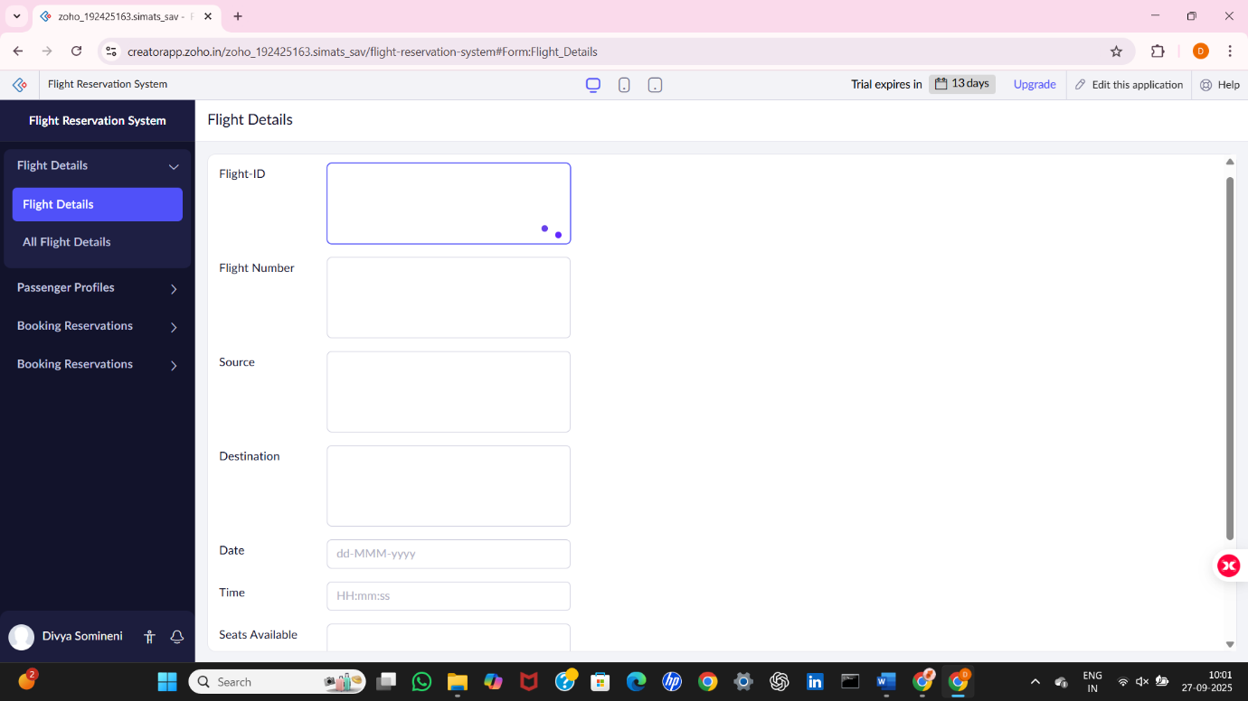
FORM 2 –Passenger Profile Form

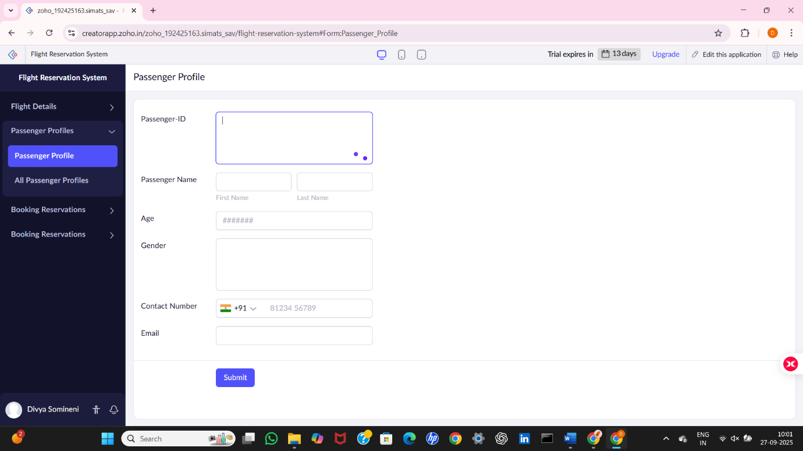

FORM 3 –Booking Reservation Form

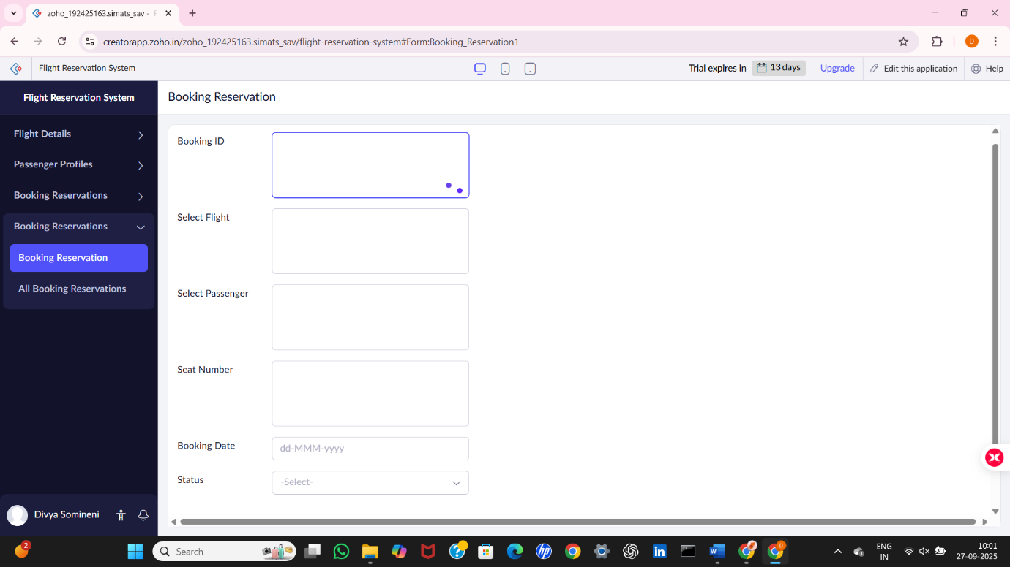

FORM 1 – Flight Details Form

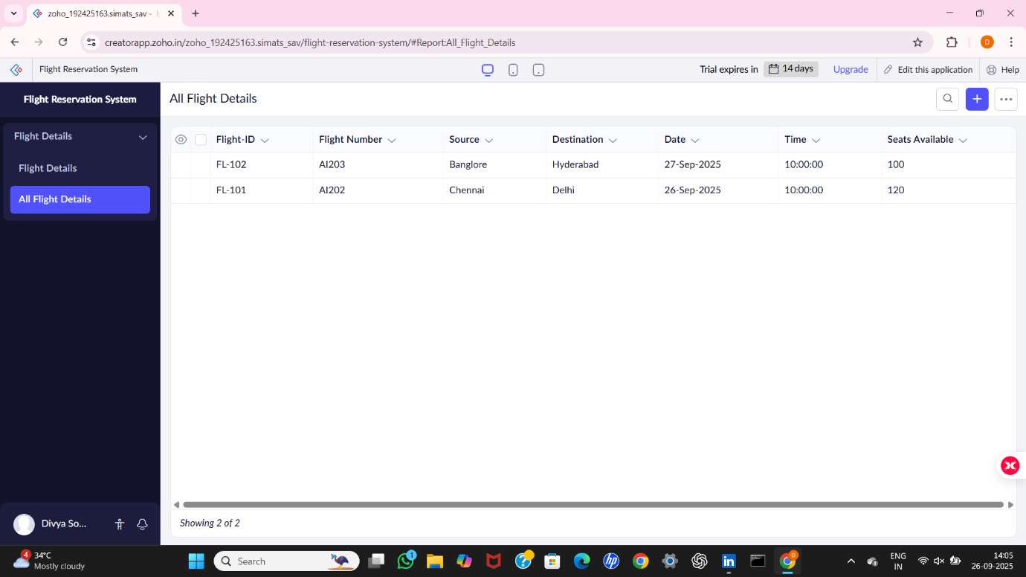

FORM 2 – Passenger Profile Form

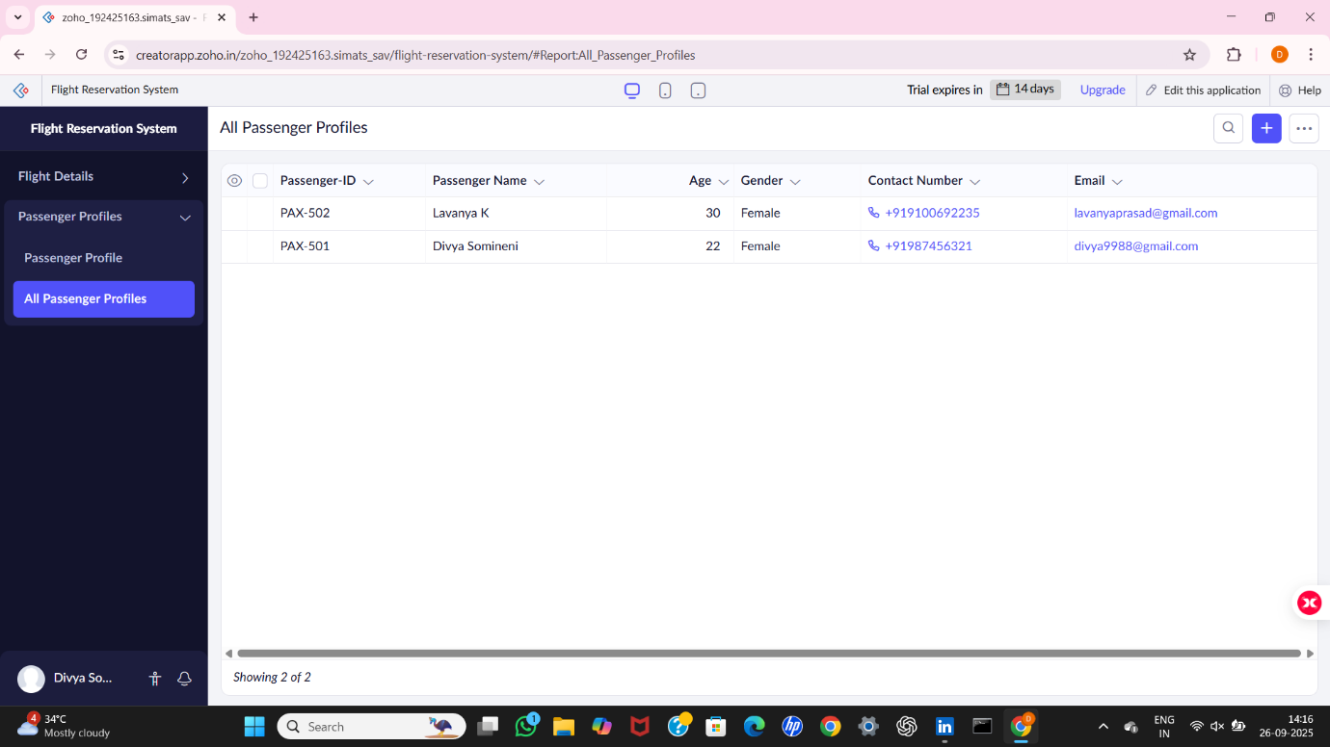

FORM 3 – Booking Reservation Form

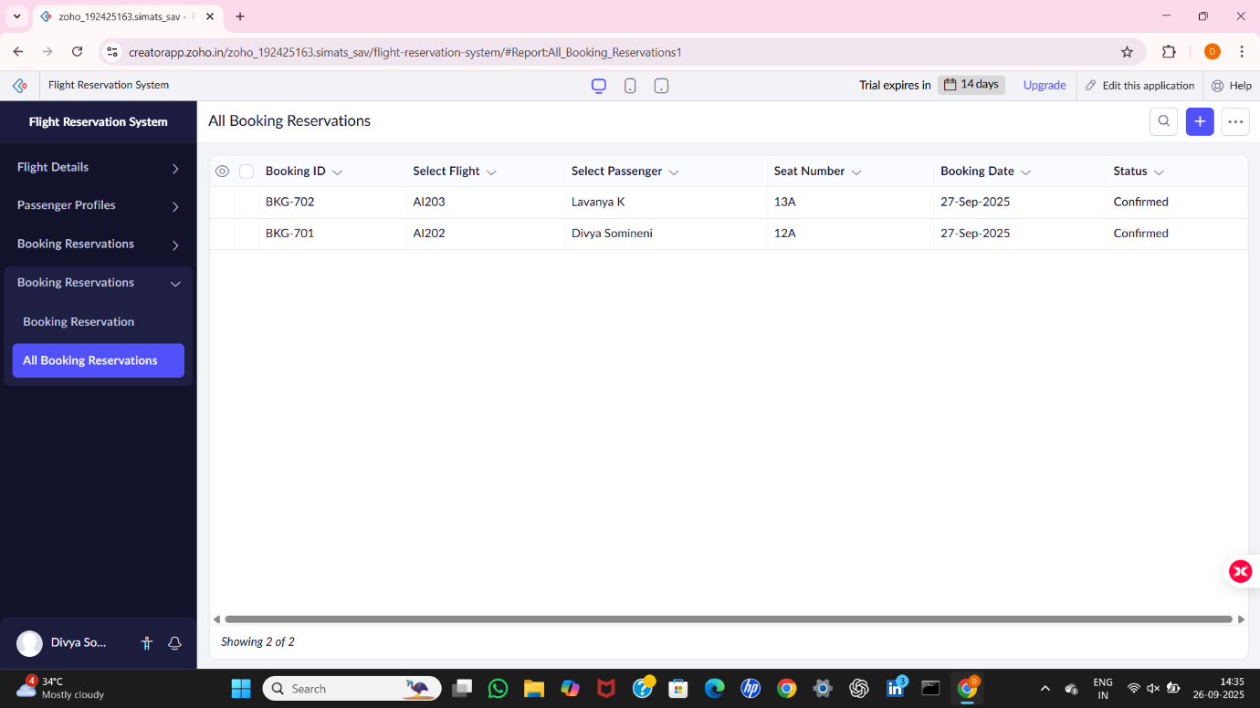

RESULT:
A Flight Reservation System was successfully created using Zoho Creator (Cloud SaaS platform) with the following forms:
- Flight_Details
- Passenger_Profile
- Booking_Reservation
This demonstrates SaaS, as users can register passengers, add flights, and make reservations entirely through the cloud without installing any software.

